 | Kincorth & Leggart Community Council  JULY Meeting Minutes  Wednesday 8th JULY 2026  Room No 7, Kincorth Community Centre

Attendees: Hazel Massie, Kirsty-Lee Murray, Ivan Irvine, Scott Sutherland, Cllr Richard Brooks, Shelagh Morrison, Chris Sumner, Cllr Alex Nicoll, Amanda Foster

Apologies: Donna Cuthill, Cllr Miranda Radley, Cllr Lynn Thomson, Patricia Watt, Joyce Leslie, Alexander Galashan, Dorothy Burke

Chairperson’s Report
Our Chair opened the meeting and welcomed everyone.

The June Minutes were approved by Shelagh and seconded by Scott; they should now be posted on Facebook and our Web page. ACTION: Secretary

Police Report
The Quarterly Police Report is attached at the end of these Minutes

Residents are very concerned about noisy youths on the grass playing fields after 9:30pm and at Kincorth Circle and the top of Provost Watt Drive. We encourage residents to keep reporting these issues and as it has been raised at this meeting, we shall report this to the Police. Action: Secretary

For information, contact the Police as follows
-  101 – Non emergency;
-  Email - AberdeenSouthCPT@scotland.police.uk
-  Twitter - @NorthEPolice
-  Facebook – www.facebook.com/NorthEastPoliceDivision
-  Web – www.scotland.police.uk
-  999 – Emergency;
-  0800 555 111 - Crimestoppers;

Councillor’s Reports
Outstanding issues from previous meeting: -

Grit bin location map and bin status –Cllr Radley was unable to attend the meeting but she passed on a message to say that this situation is still being looked into. Cllr Nicoll looked at the map location on the ACC site and thought that it might probably be up-to-date. Cllr Nicoll also said that he thought that the Grit Bin behind the Doctors Surgery was not the responsibility of the Council and that it probably belonged to the Health Board.

If you wish to see where the grit bins are located on-line, the best site is the following: -

www.aberdeencity.gov.uk/council-services/roads-parking-and-travel/gritting/

It takes you to the first page which has the Community Grit Bins / Grit Bin and Damaged Grit Bin links. It also has a link to the gritter routes. There is a specific route detail further down the page for Kincorth Cove and Altens.

The following is the map of community and grit bin locations:-

https://experience.arcgis.com/experience/fbe37e774d8542758649c72d1849944e

The link from “find a grit bin” opens in the Council interactive mapping system. Just fill in the search box at the top right corner with what you are looking for and the map will highlight the asset. Works for recycling points, gritting boxes, electoral wards etc.

Action: Secretary to email Cllr Radley to request an update and clarification of ownership of the grit bin behind the Doctors Surgery.

Council Payment Machine within Kincorth Community Centre, FS-Case-811139283
Thanks to Cllr Brooks continually chasing the removal of this Machine, it has now been removed from the Community Centre Foyer. We thank Cllr Brooks for his persistence on this matter.

Provost Watt Drive, pedestrian crossing to the Spar, FS-Case-837701313
This has been raised by residents and to further enhance the issue KLCC members will try to organize proof of the problems posed either by photography or video. Action: KLCC members

Craighill Housing, play areas: FS-Case-797964523
The Committee queried the small play areas provided at the housing which are wooden facilities which will not stand the time and are not accessible by everyone. Cllr Brooks was going to talk to the architect and forward our comments. Action: Cllr Brooks will chase feedback to our comments.

Poor signage on Faulds Gate
At our previous meeting we reported the poor signage on Faulds Gate and forwarded photographs to show those signs that caused concern. Cllr Brooks has informed us that all the signs reported will now be replaced within the next 6 weeks. Thanks was given to Cllr Brooks for his support on this matter.

Kincorth Flooding Issues, Ref: FS-Case-811152569 no update and issue outstanding for next meeting. Action: Cllr Brooks

Community Bus, Ref. FS-Case-817182791
Lochside Academy are happy to provide access to their minibus if all necessary checks and insurance requirements can be satisfied. The following is feedback from Cllr Nicoll.

Volunteers may be permitted to drive a Council Minibus if they have a Council Minibus Permit and if the organisation they are driving for are an Approved Hirer. The permit must be applied for and is subject to a minibus assessment being undertaken and passed, which costs £50.00. To become an approved hirer also requires an application to be completed for consideration by the relevant Chief Officer. The Community Centre and Community Council can get more information and access to the application forms from:- CommunityTransport@aberdeencity.gov.uk

The Passenger Transport Unit used to have vehicles available for hire, but due to underutilisation these are no longer available, and it is rare that vehicles are available during working hours and typically hires are only available out with these hours.

There are some assisted travel services available in Aberdeen, which may be of benefit, as follows:
- Aberdeen City Council’s Community Transport service. This is a dial-a-bus service which operates Mon – Fri, between 10:00 – 14:30 and is fully wheelchair accessible. Further information can be found at: www.aberdeencity.gov.uk/council-services/roads-transport-and-parking/community-transport/ or by calling 01224 070 900.
- THInC Transport. THInC is the Transport to Healthcare Information Centre for the NHS Grampian area which provides advice on travelling to health or social care appointments. A transport service funded by the City’s Health & Social Care Partnership through THInC is in operation in Aberdeen to transport people to health and social care appointments operating Mon – Fri between 08:30 – 17:00 and is fully wheelchair accessible. Further information can be found at: http://thinc-hub.org/. Bookings can be made by calling: 01467 536111.

The Passenger Transport Unit may be able to provide a vehicle and driver to support some activities, although our availability is limited. We would be happy to speak to the Community Centre and Community Council to get more information on their requirements to see if there is anything we can help with, they can contact us at:
FleetTransport@aberdeencity.gov.uk

A final option is that the Criminal Justice Team do provide some minibus transport for sheltered housing to access supermarkets. Not sure what availability they may have or whether they could provide any support, but it may also be worth reaching out to them and they can be contacted at:
CJAdmin@aberdeencity.gov.uk

Thanks go to Cllr Nicoll for investigating this request. This feedback has been passed on to relevant interested parties within the community.

Cllr Brooks informed the members that issues raised with parking problems on Corthan Crescent have been reported and that Traffic Wardens are now checking the street on a regular basis.

Cllr Nicoll reported to the committee that he has had some residents reporting issues regarding the new Voi bikes located within Kincorth. If you wish to know more about these bikes and how the system works, please visit: www.voi.com

The Committee asked Councillors if there is any equipment they have to help wheelchair users access the green space currently used for football. Unfortunately, there is nothing available.

Treasurer Report
Unfortunately, our Treasurer was unable to attend the meeting, but by email informed the Committee that there was no expenditure for this period. He also gave an update on the potential of joining a Credit Union: it would be a good way to support local people and keep some of its money working within the community. Credit Unions also offer fairer savings and affordable loads if needed. It could be a positive option for holding some spare funds whilst still keeping the main account for everyday use.

Legends Family Fun Day Event, 25th July
KLCC will have a tombola stand at the event and are currently sourcing donations. Action: Members

The Committee agreed to donate £100 to the Kincorth Football Club and the Kincorth Community Centre Hub in support of the event. Action: Treasurer

Planning Report
HazelntsNBrambled Project
No updates to report.

NESTRANS picnic table installed at the top of the hill and bench location to be identified.

South Harbour Road Link and Wellington Road Corridor
Await feedback on joint CC’s concerns.

KLCC Web Site
One of our Committee Members has kindly taken on the role of tidying up our current web site which is out of date and needs to be modernized. In order to achieve this, KLCC may need to invest more money in the application. A meeting is to be organized with interested members to discuss what we want contained on our site and how we wish it to look. Action: Ivan to arrange a meeting

KLCC Survey
The subgroup are meeting on 16th July to review the collective feedback from the event and to formalize the way forward. Hopefully any actions identified will align with Community Planning and possibly supported by Ogilvie Construction who are keen to invest in projects in the area.

The Community Consultation: Analysis Summary Report can be viewed on our Web Page. Link: https://klcommunitycouncil.org.uk/community-survey/

Gardner Residents Project
Members met on the 12th of June. We decided where we would like a new bench to go. Hopefully this will be installed soon.

Members would like to do a picnic and pick up on the 7th of August. This will show the Council that residents continue to do their part for the community.

We would like to see some action on the areas addressed on the walk around in January. For example, the road gulleys on Gardner Crescent still have not been cleaned out although the weeds growing from the drains have been sprayed with weed killer.

Residents have been great at reporting fly tipping, and we hope the Councils fly tipping hit squad are visiting the area regularly.

We need more volunteers and your voice matters, make them heard by joining in the Gardner Community Group, contact us at gardnergreenspace@gmail.com or dcuthill@aberdeencity.gov.uk

Kincorth Bowling Green Development
Northing to report at present as we are awaiting feedback from Council Officers who will be assessing the area and preparing the Business Case presented at the next Finance & Resources Committee meeting due August/September 2026.

Deevale Community Garden
(accessed via the lane at the corner of Cairnvale Terrace and Deevale Gardens)
Thank you to Councillor Nicoll for making enquiries regarding our shed. We do not need planning permission and can now arrange the build.

The gardens 3rd birthday event on 4th July was a great success with over 100 attendees, and we raised £100 through donations. The musicians were well received, and all activities were well supported. We were delighted to have several visitors from the Affinity Trust who had first use of our new wheelchair accessible raised beds.

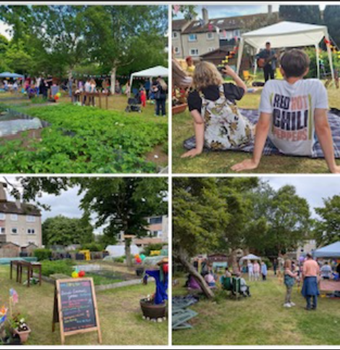

Gardners are investigating the potential of an accessible path and Cllr Nicoll recommended speaking to the Cove Woodland Trust.

Our constitution has been agreed, and a meeting will be arranged soon to establish our committee.

ACC 24hr Litter Pick, 18th June
The event went very well and KLCC members were joined with representatives from the El Shaddai Church.


AOB
Laptop and Printer
We are still looking at the costs associated with the purchase of a laptop and printer for the Committee to use. Members will seek feedback from any IT knowledgeable friends they know and we can discuss it at our next meeting. Action: all members

Co-option of New Community Council Member
Two members who are currently Associate Members would like to become full Community Council members. They have completed the necessary paperwork and this will be submitted to the Community Council Liaison Officer for approval and after a six-month period they will be full members. Action: Secretary to forward completed forms

Date of Next Meeting
12th August 2026 in the Kincorth Community Centre, Room 7 at 18:30 hrs.

Date of future Meetings - all within the Community Centre, Room 7, starting at 18:30 hrs.
9 Sept, 13 Oct, 11 Nov, no December meeting.


QUARTERLY REPORT – Aberdeen City South – Nigg CPT
This report provides an update on all Policing matters in the South Aberdeen area covered by Nigg CPT between the 1st of March and the 31st of May 2026.
Nigg CPT covers – Nigg, Cove and Altens, Garthdee, Kincorth and Leggart.
The report aims to highlight emerging trends and issues in your area and any ongoing campaigns.
Our focus is aligned with the Force Priorities to reduce crime and disorder, help create safer communities and respond effectively to local concerns. Although we do not intend to produce detailed statistics or comparison data a light touch overview will be provided.
• Anti-Social Behaviour, Violence & Disorder
• Road Safety and Road Crime
• Protecting Vulnerable People
• Acquisitive Crime
• Serious and Organised Crime

COMMUNITY POLICING INSPECTOR COMMENTS
Looking Back:
Most notably during the previous three months has been the ongoing issue of “car meets” which tend to start at the beach and then migrate to the car park at Asda, Garthdee. This has resulted in the store having to close early on occasion and causes considerable distress for patrons and nearby residents due to the noise and generally intimidating atmosphere.
On 30 May, in response to information that there would be a large scale meet in Aberdeen, a plan was put in place involving more than 30 police officers. As anticipated, the meet started at the beach area before moving to the car park at Asda, Garthdee with several hundred vehicles in attendance, and reports of anti-social, careless and dangerous driving being received.
Most of the police resources attended at Asda and effectively closed the car park. During a 3-hour window over 730 vehicles were stopped and checked whilst leaving the car park. The following offences were detected:
2 x arrests for drug driving
2 x drug possession
14 prohibitions
3 x Section 165 seizures
8 x Vehicle defect forms
54 x conditional offers for variety of construction and use/MOT offences
It is anticipated that further offences will be detected following a review of CCTV footage and various social media posts relating to the meet.
Subsequently, I have met with the management of Asda to discuss ways to target harden the car park and make it an unattractive option for those persons involved in these meets.
- They will switch their parking monitoring IT system on 24 hours a day. The hope is that it will generate parking tickets against repeat offenders and whilst nobody ever pays the fines, the hassle of getting repeat letters from the parking enforce company will be just that.
- They have funding from their estates office to install further speed calming measures in the covered section of their car park which is where most of the issues occur because the attendees use it as a drag course. They are looking to expedite this. I have also encouraged them to have the capacity to close the covered section entirely by using simple chains which can be deployed quickly by staff as and when they feel the need.
More generally I can report that acquisitive crime has remained at the same level as the previous quarter with the south of the city in general performing well in this respect.
We continue to deal with violence daily across a variety of settings. Dealing with these types of enquiries remains a priority for us in particular where we identify that the victim has vulnerabilities.
Our Proactive and Organised Crime Units continue to work tirelessly across the entire city and Aberdeenshire and Moray to combat the sale and supply of drugs with considerable success.
Looking Forward:
The issue of car meets at Asda will remain a priority; we cannot assume that the problem will disappear overnight simply because of our actions on 30th May. I will remain in regular contact with the management at the store and we will continue to support the store with patrols and targeted action where we can.
Over the summer period I anticipate that the Gramps will be the focus of Fireraising calls. Our colleagues from SFRS have been delivering inputs to local schools along with our schools’ officers to educate young people about danger of deliberately setting fires and we will have dedicated patrols during the summer holidays in and around Kincorth to try and deter any such behaviour.
Gavin Grant
Inspector
Nigg Police Office

Anti-Social Behaviour, Violence & Disorder:
Anti-Social Behaviour remains an area where we aim to facilitate early interventions for those vulnerable to involvement in anti-social behaviour, violence, and disorder. To identify locations where such behaviour is likely to happen and try to identify solutions to potential problems.
Police Scotland aims to target locations where a high number of calls indicating local disruption are identified. The areas identified are determined by local intelligence and calls received from members of the public.
We will continue to respond to incidents that are brought to our attention and where particular ‘Hotspots’ are identified we will direct resources appropriately to counter those behaviours. Where ‘Hotspots’ are identified these will be highlighted in future reports.
Given the impact the behaviour of a small minority can have on a community it is important that the Communities we serve make us aware of these issues at the time they occur. This will afford us the best opportunity to respond appropriately and have a positive impact on the people involved in anti-social behaviour.
On the 29th of April 2026 officers executed a warrant at a property on Pitmedden Road in the Garthdee area of Aberdeen whereby they recovered 355 Cannabis plants with a six-figure value. A 40-year-old male was arrested and charged in relation to drug offences and has been remanded in custody.
An increasing number of cannabis cultivations are being found within rental properties which are solely being used to grow illegal drugs. Many of these properties also have electricity meter bypassed to gain power illegally. We remain committed to disrupting the supply of controlled drugs in Aberdeen and through proactive work continue to seize and dismantle a significant number of illegal substances each month.
Road Safety and Road Crime:

Road safety and road crime is a priority for Police Scotland.
We continue to actively monitor roads across the CPT area and conduct speed checks to educate drivers. Speed checks were carried out in the communities that have recently had the 20mph limit implemented due to concerns raised by local residents.
Where concerns are raised regarding driver behaviour, we will continue to liaise with the local authority with a view to securing their assistance with speed surveys which may in turn provide the necessary evidence to warrant the deployment of North East Safety Camera Partnership resources in those areas.
Due to the increased complaints from residents and members of the community in relation to the use of off-road bikes on grassy areas and residential streets, Police Scotland instigated Operation Armour.
Operation Armour is an intelligence led operation relating to the criminal and anti-social use of E-Motorcycles, adapted E-Bikes, E-Scooters and petrol motorcycles across Aberdeen City.
Between 18 May and 5 June 2026, the Community Action Team identified a number of nominals that had access to E-motorcycles and made efforts to identify where they were being utilised and stored. Various nominals and addresses were identified throughout the City.
The unit also focussed on the delivery drivers that utilise e-bikes in the City Centre and a number were found to have been adapted and deemed illegal.
During the three-week Operation a total of 154 Crime Reports have been raised. Warrants were obtained which assisted in the recovery of some of the vehicles. The following recoveries were made during the Operation;
5 x SurRon style Electric Motorcycles
19 x Adapted E-Bikes (delivery drivers in the City Centre)
15 x Electric Scooters
5 x Petrol motorcycles
1 x Van
1 x Car
32 grams of Diamorphine
1.3 kilogram of Cannabis
£2195 in cash
In total, 50 nominals have been charged with various road traffic offences, which include dangerous Driving, Disqualified Driving, driving an unregistered vehicle without a licence, driving an unregistered vehicle without insurance, driving on footpaths and not wearing a crash helmet. 4 nominals have also been charged with drug supply during the operation.
The Community Action Team are continuing to generate intelligence about individuals that are using e-bikes and e-motorcycles illegally and are also keen to identify storage locations for these. If you have any information that could assist, then you can report this via 101 or by emailing northeastcommunityactionaberdeencity@scotland.police.uk.
Overall, during the operation 34 individuals were prosecuted for a total of 93 crime reports. These included various road traffic, drug and other offences. 23 e-bike and e-motorcycles and 8 e-scooters were also seized for illegal use. Of these 34 individuals 27 were charged with riding with no insurance and 17 for riding without the relevant licence requirements/having no license. 2 were charged with being concerned in the supply of a controlled drug and others were charged with being found in possession of a controlled drug.
The Community Action Team are continuing to generate intelligence about individuals that are using e-bikes and e-motorcycles illegally and are also keen to identify storage locations for these. If you have any information that could assist, then you can report this via 101 or by emailing northeastcommunityactionaberdeencity@scotland.police.uk.
On Saturday 2 May officers were called to attend a report of a crash involving a female and an off-road motorcycle in the Garthdee area of Aberdeen. The 29-year-old female was taken to Aberdeen Royal Infirmary where she received treatment for serious injuries. The 43-year-old male responsible was arrested and charged with attempted murder along with other road traffic offences for the incident.
SERIOUS ORGANISED CRIME:
There are always a number of operations being run within Aberdeen city with regards to serious and organised crime.

Serious and organised crime (SOC) is tackled using the 4D strategy “Disrupt, Detect, Deter and Divert”. This allows Police alongside partner agencies to proactively collaborate together and support those most vulnerable from the effects of SOC and drug misuse in our local community.
Officers also continue to stop and search persons using Police powers to search for Possession of Controlled Drugs and Offensive Weapons with several seizures of both.
Information from the community is vital. Any information received will be acted on and the community is asked that anyone with information or concerns contacts 101 or Crimestoppers anonymously. Police Scotland are determined to protect the public from this harmful criminality by disrupting the drugs trade and preventing their manufacture and distribution.

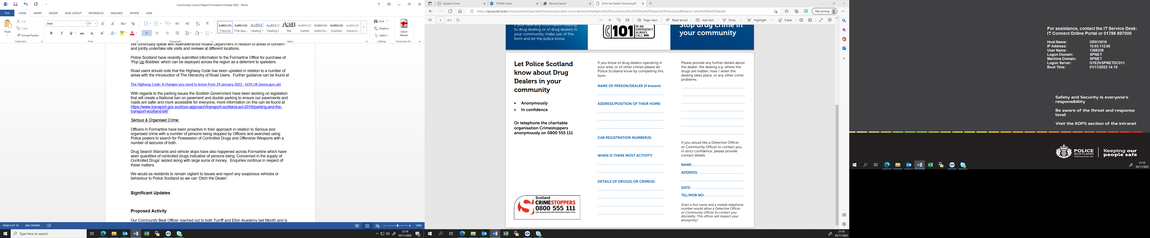

The above image attached is a form for CrimeStoppers- I am sharing this in case this is something new to some. It is very important that members of public who have any form of intelligence surrounding illegal activities that may be going on in their local communities come forward as this builds a bigger picture in terms of Policing and helps us reach a safe conclusion. CrimeStoppers is a great tool to have, and members of public can report things anonymously if they wish.

ACQUISITIVE CRIME:
Acquisitive crime encompasses a number of crimes such as Theft by Housebreaking, Vehicle Crime, Shoplifting, Fraud and Theft.
In March 2026 the Community Action Team led two productive days of action with an operation focussed on retail crime in Aberdeen. As a result, a 60-year-old man and a 49-year-old woman were charged in relation to 8 thefts by shoplifting. The 60-year-old was also arrested on an outstanding warrant. Men aged 41, 42 and 45 old were reported to the Procurator Fiscal in connection with 9 further Thefts by Shoplifting. A 38-year-old woman was arrested on warrant and was charged with 3 theft by shoplifting, 1 attempted theft by shoplifting and 2 offences under the Protection of Retail Workers (Scotland) Act 2021.
The operation was deemed a success with high tariff repeat perpetrators disrupted.
Shoplifting is not a victimless crime and can have a detrimental impact on businesses and employees. We work closely with retailers and partners to disrupt and detect retail crime and continue to bring offenders to justice.
PROTECTING VULNERABLE PEOPLE:
During March 2026 Police Scotland Partnerships, Prevention and Interventions team focused on rolling out the Distress Brief Intervention (DBI) Service among operational officers. The Distress Brief Intervention service provides support to people who are experiencing distress and feeling overwhelmed emotionally. This service provides a quick response which listens and supports with a sensitive, caring and non-judgemental approach. Operational officers can now refer individuals using their mobile device which is taken with them to every job. The service is provided through Penumbra 365.
Penumbra 365 is based in Aberdeen and is intended to be “a single point of access” for people who are 18+, resident in Aberdeen and seeking mental health, well-being, or distress support. The aim is for practitioners to provide the appropriate in-person crisis support, prevent escalation, provide a recognised point of access and to act as a much-needed diversion from hospital or custody. It also allows practitioners to do a thorough assessment, particularly helpful as often this acts as a gateway for signposting to other support services. By providing mental health support immediately and putting follow-up steps in place to support that person out of crisis, this helps to avert future crisis. Police Scotland are able to sign post persons seeking mental health support to Penumbra 365 and this has proved highly effective.
So far, the feedback from this new Distress Brief Intervention (DBI) Service has been positive and operational officers are more regularly using this to help vulnerable people in need.
A wealth of information and advice relating to home security as well as other Police related matters can be accessed on the Police Scotland website at: https://www.scotland.police.uk/advice-and-information/
Scams
In Scotland, report all scams to Advice Direct Scotland by calling 0808 164 6000 (Mon-Fri 9am-5pm) or online at www.consumeradvice.scot
Fraud
If you have been the victim of fraud, report it to Police Scotland on 101 or 999 in an emergency.
Suspicious Emails
You can forward suspicious emails to report@phishing.gov.uk and send links from websites which you think are trying to scam the public to the National Cyber Security Centre's scam website reporting service at www.ncsc.gov.uk/section/about-this-website/report-scam-website
Suspicious Text Messages
If you receive a suspicious text message you can forward it to 7726. The free-of-charge ‘7726’ service enables your provider to investigate and take action if malicious content is found.
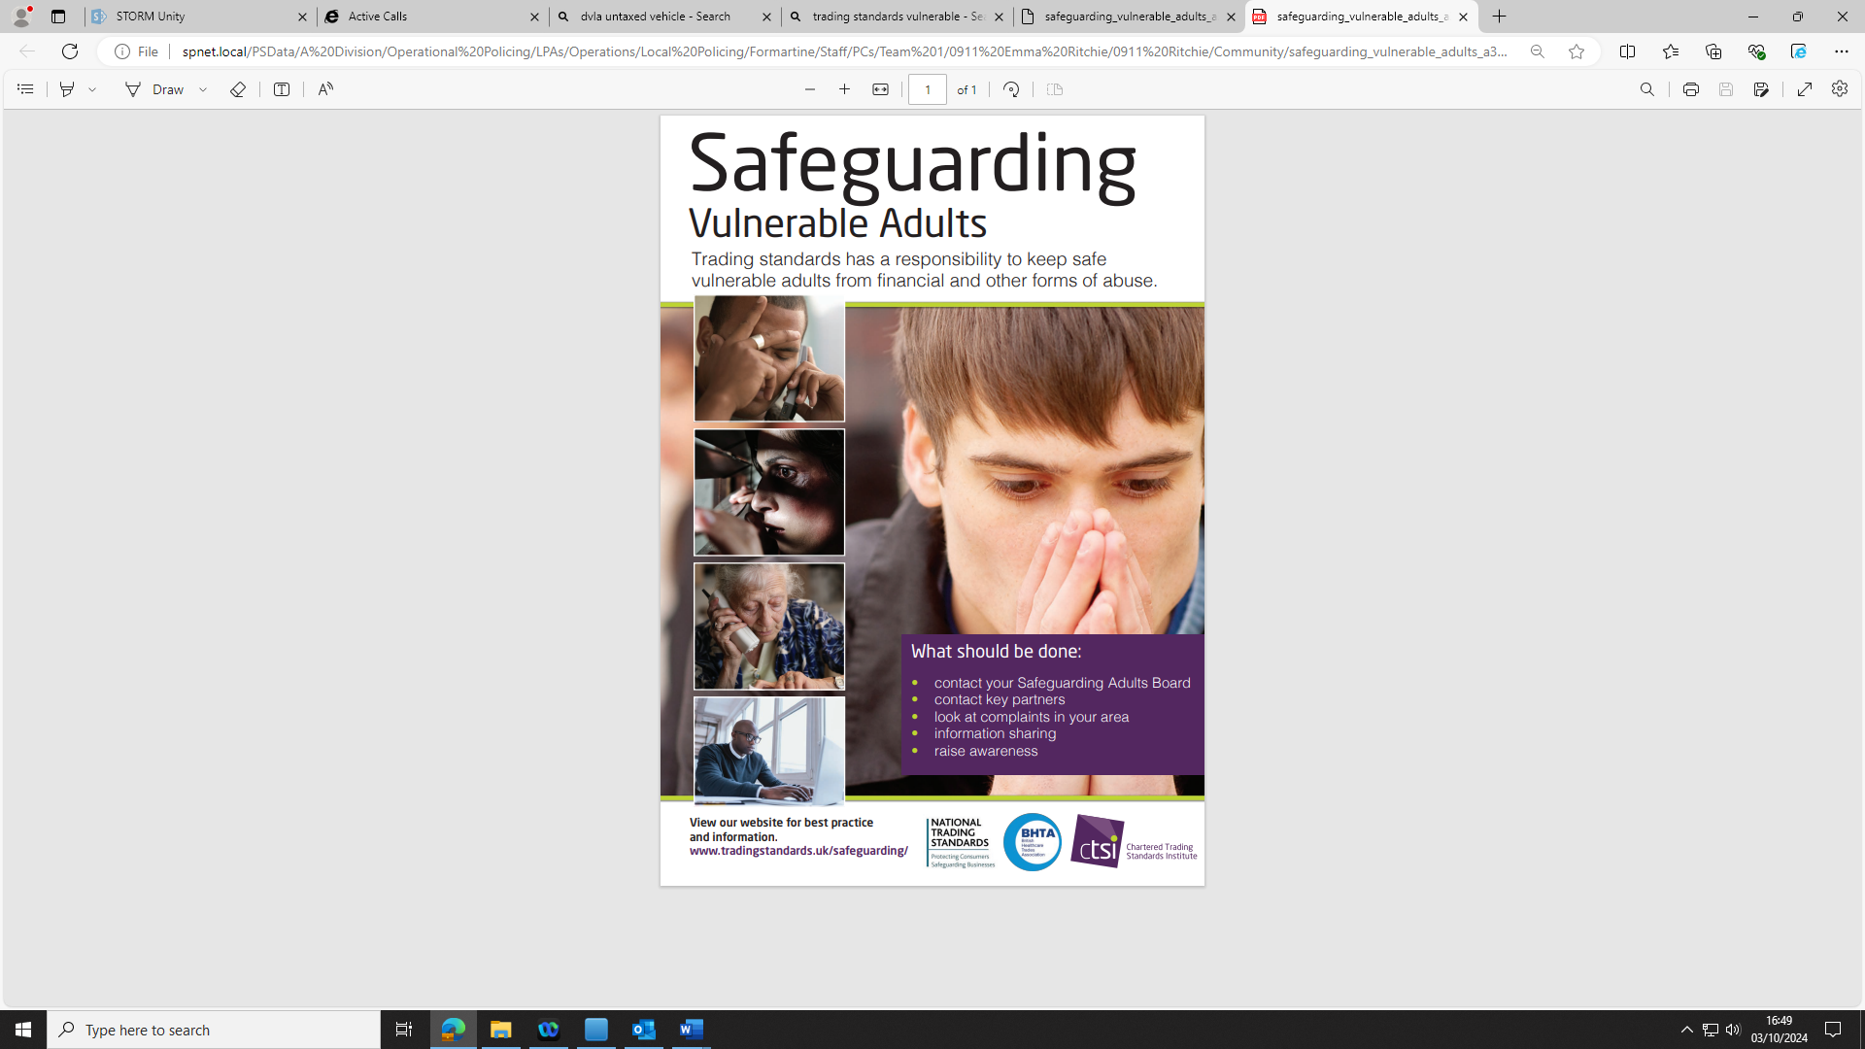

Social Media and Feedback
There may be updates on Police action in your community on Social Media sites as below:
Facebook- www.facebook.com/PoliceScotlandNorthEast
X- x.com/psosnortheast
Any feedback, please send an email to
northeastcptaberdeencity@scotland.police.uk or report matters of criminality or anti-social behaviour via 101.

