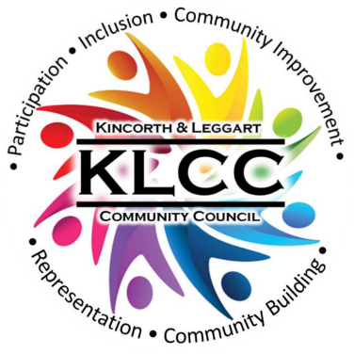 | Kincorth & Leggart Community Council  JUNE Meeting Minutes  Wednesday 15th June 2026  Room No 7, Kincorth Community Centre

Attendees: Hazel Massie, Kirsty-Lee Murray, Ivan Irvine, Scott Sutherland, Joyce Leslie, Cllr Richard Brooks, Shelagh Morrison, Chris Sumner, Cllr Alex Nicoll, Alexander Galashan, Dorothy Burke,

Apologies: Amanda Foster, Donna Cuthill, Cllr Miranda Radley, Cllr Lynn Thomson, Patricia Watt

Chairperson’s Report
Our Chair opened the meeting and welcomed everyone.

The May Minutes were approved by Scott and seconded by Joyce; they should now be posted on Facebook and our Web page. ACTION: Secretary

Police Report
Police Scotland are aware of ongoing issues within the area and have asked that residents keep reporting them.
For information, contact the Police as follows
-  101 – Non emergency;
-  Email - AberdeenSouthCPT@scotland.police.uk
-  Twitter - @NorthEPolice
-  Facebook – www.facebook.com/NorthEastPoliceDivision
-  Web – www.scotland.police.uk
-  999 – Emergency;
-  0800 555 111 - Crimestoppers;

Councillor’s Reports
Outstanding issues from previous meeting: -

Flooding Issues – Ref: FS-Case-811152569
We have an issue with blocked road gulleys not being cleaned (in general) in Kincorth.
Action: Cllr Brooks will continue to chase for action

Grit bin location map and bin status – Cllr Radley working on identifying the condition and location of each bin in the Kincorth area and will email her findings to the Committee. Action: Secretary to email Cllr Radley for an update

Housing Development Obligations
Ogilvie Construction were unable to attend our June meeting, but the members agreed that this issue should be discussed at the next Open Space catch-up meeting. Action: Secretary to email Donna to request a date for the next meeting.

Council Payment Machine within Kincorth Community Centre, FS-Case-811139283
Cllr Brooks has raised this removal and been informed that arrangements are in progress to remove the machine. ACC are currently obtaining quotations for the most appropriate method of removal and disposal. Action: Cllr Brooks

Provost Watt Drive, pedestrian crossing to the Spar, FS-Case-837701313
Officers have attended the site and looked at the condition of the dropped kerbs and the potential difficulties this may be causing for wheelchair and mobility scooter users and appreciate the concerns being raised but the Roads Inspector has made an assessment and confirmed that the crossing points at this location are in good condition.

Committee Members politely disagreed with this assessment and feel that further action is required. Action: Committee Members will talk to residents of the community who reported these issues and take photos and if possible a video which will highlight the problems and will forward this to Cllr Brooks.

Craighill Housing, play areas: FS-Case-797964523
The Committee queried the small play areas provided at the housing and although there are 5 areas they are small wooden facilities which will not stand the time and are not accessible by everyone. Action: Cllr Brooks will go back to the Planning Service and the architect with our comments.

Cairngorm Road, safety issue with children crossing: FS-Case-653507137
ACC response is that there were no proposals to install a signal-controlled pedestrian crossing at the location referenced. However, new and improved dropped kerb crossing points have been delivered adjacent to the Faulds Gate / Cairngorm Road / Gardner Drive roundabout. These crossing points incorporate tactile paving to assist visually impaired pedestrians and were implemented as part of the nearby housing development, where improvements to adjacent pedestrian routes were secured through the planning/roads construction consent process. The other section of Cairngorm Road that is under consideration was at its junction with the A92 Stonehaven Road, where there are not currently ‘dropped kerbs’ for pedestrian passage, and where we are considering an improvement in terms of providing a formal ‘dropped kerb’ crossing point and insetting it away from the immediate junction face. It’s appreciated this was not the original location you highlighted; however, it is one, where in terms of modern design, there would be a preference for a ‘dropped kerb’ to facilitate pedestrians crossing. The design is still being considered, as it involves extending the footway on the south side onto grass verge currently maintained by the Environmental Services Team. Any progression to delivery would be subject to the availability of funding and competing priorities. It is acknowledged that there may be disappointment that a signal-controlled pedestrian facility is not proposed on Cairngorm Road in the vicinity of the roundabout However, an assessment of the location indicates that such a facility would not be justified, given its residential character and modest levels of pedestrian and vehicular activity. In these circumstances, pedestrians would be expected to cross the carriageway safely by exercising reasonable care, while drivers are required under the Highway Code to remain alert and give priority where necessary to vulnerable road users, including pedestrians.

Abbotswell PTA wanted the poor signage on Faulds Gate resolved and it was agreed that members would forward pictures of the poor signage to Cllr Brooks to highlight the concerns. Action: Photos to Cllr Brooks

Youth Club based at Kincorth Community Centre: FS-Case-808094747
On 6th March 2026 we asked: Can officers confirm if there has been until recently a Council run Youth Club based at the Kincorth Community Centre, this seems to have ceased. It was to ascertain if the funding for this has been withdrawn or directed elsewhere in the Community, and if the lack of provision is in line with that of other areas.

ACC response (16th March 2026): The Education and Lifelong Learning service:- A Council run youth club operated at Kincorth Community Centre until July 2025. The service was closed after the Development Group that manages the centre introduced a charge of £44 per evening for access, despite the fact that our youth workers were acting as keyholders and taking responsibility for opening and closing the building. This cost was beyond our available budget, When the Development Group was reminded that the terms of their licence to occupy the building included an expectation of free access for Council services benefiting the community—where the space was not otherwise booked—they instead chose to let out the rooms needed for the youth club to other activities. Our budget for community based youth provision is extremely limited, and the funding previously used at Kincorth has now been reallocated to support provision in another area.

Cllr Nicoll said that he is still trying to organise a meeting re the sports facilities which ties into the Kincorth bowling green development. He will keep us informed.

Cllr Nicoll also informed the Committee of various footpath and pavement upgrades taking place and said he would send the link to the committee which allocated funding for the coming year on a range of roads and pavements etc requiring repairs. Action: Cllr Nicoll to send link

Treasurer Report
ACC annual grant received along with funding from NESTRANS. KLCC donation made to the Deevale Community Garden.

Whilst we await the final set up of new members to the TSB Bank Account, our Treasurer will look into the Aberdeen Credit Union and report back at the next meeting. Action: Treasurer

Planning Report
HazelntsNBrambled Project
No updates to report.

NESTRANS funding granted for picnic table and bench, in progress.

South Harbour Road Link and Wellington Road Corridor
The 4 Community Councils met on 3rd May to discuss their collective concerns and approval was given from KLCC to send a formal letter to the Chief Executive. There will be another meeting of the 4 CC’s on 21st June. Action: KLCC representatives

KLCC Survey
When the collective feedback from this event has been received, a meeting will be planned so that we can discuss the findings. Hopefully this will help tie in with any Ogilvie Construction Group developers’ obligations. Action: Secretary to organize with Donna and sub-group.

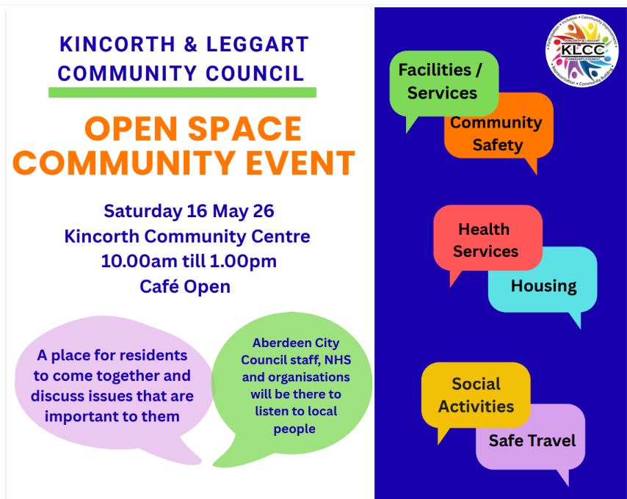 | 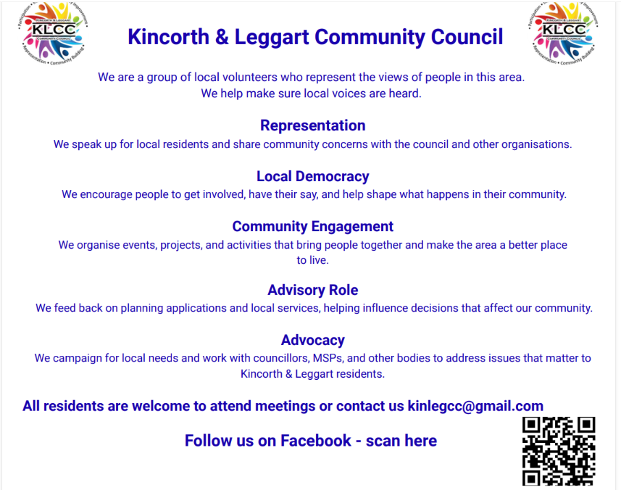

The Community Consultation: Analysis Summary Report can be viewed on our Web Page. Link: https://klcommunitycouncil.org.uk/community-survey/

Notice Boards
The Gardner Shops Notice Board has been installed and we hope to have another at the Kincorth Shops. There will be two key holders for the boards i.e. Kirsty-Lee and Hazel who will each have access to display and remove events.

If you have an event that you would like displayed on the Notice Board please email the KLCC on kinlegcc@gmail.com

Here is the Notice Board at the Gardner Shops which has two sides to display articles.
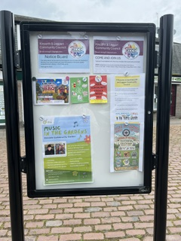 | 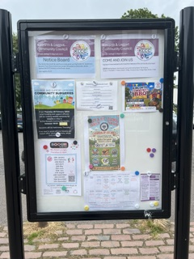

Kincorth Bowling Green Development
Northing to report at present, we await feedback from Council Officers who will be assessing the area and preparing the Business Case which will be presented at the next Finance & Resources Committee meeting due August/September 2026.

Deevale Community Garden
(accessed via the lane at the corner of Cairnvale Terrace and Deevale Gardens)
The gardeners have been busy with spring planting, and the occupied plots are looking green and productive.

One gardener has given up a plot due to other commitments, and one new gardener has joined recently.

Many thanks to KLCC for the donation towards the 3rd Garden Birthday Event. We bought lots of bedding plants.

Thank you to KLCC for agreeing to continue holding Deevale Community Garden funds once the garden group become constituted.

The gardeners are having a Polytunnel Maintenance weekend 13th and 14th July.

A request was made to the Committee to ask if they would submit a planning application to build a shed in the garden area, on behalf of the garden group, as community councils receive a 50% discount on the planning fee. The garden group will then consider how to raise the funds for the reduced fee. ACTION: Cllr Nicoll said he would look into this for us and report back.

The Deevale Community Garden 3rd Birthday Event will be held on 4th July between 1.30pm and 4.40pm. We are delighted to be working with Cfine having been successful in applying for a 'Music in the Gardens' event. All residents welcome.
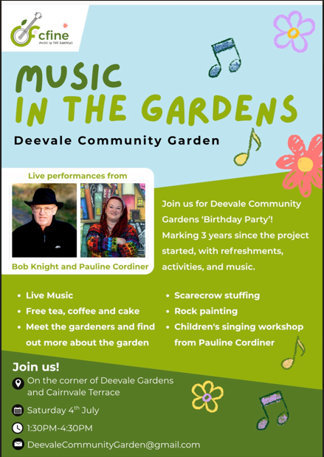

Gardner Residents Project
We are delighted that we have a date for our next meet up on Friday the 12th June at 1pm and we look forward to deciding on how to spend our grant money.

Unfortunately, there have been no improvements to the communal landings i.e. doors are not secure, people are coming in, stealing packages and taking drugs.

The road gully's still have not been cleared and the issues with the broken gutters and drains causing issues in the green spaces, have not been addressed.

We continue to encourage residents to report these very necessary repairs.

We need more volunteers and your voice matters, make them heard by joining in the Gardner Community Group, contact us at gardnergreenspace@gmail.com or dcuthill@aberdeencity.gov.uk
AOB
Champion Street Children’s Football Tournament dates have changed to 5th July – 1st August.

ACC 24hr Litter Pick, 18th June
KLCC will be participating in the event meeting at 7pm at the Gardener Shops. Representative from the El Shaddai Church have shown an interest in joining the event. Action: Secretary to give feedback from the event

Kincorth Family Fun Day & Legends Day, Saturday 25th July
KLCC will have a Tombola stall and all members have been asked to source items for sale on the table. Action: KLCC members

KLCC Pop-Up Banner
The committee chose the layout for the banner. Action: Secretary to purchase

Laptop and Printer
It was agreed that the purchase of a Laptop would be discussed at the next meeting after further investigation and members will seek guidance from experts they know.

Unfortunately, there can be no sharing of the KLCC Gmail Accounts unless each member has a gmail account and as members all felt that they had enough email accounts already they did not want to add more. Action: Secretary to keep looking to sourcing a laptop and gathering feedback from IT associates.

Date of Next Meeting
8th July 2026 in the Kincorth Community Centre, Room 7 at 18:30 hrs.

Date of future Meetings - all within the Community Centre, Room 7, starting at 18:30 hrs.
2 Aug, 9 Sept, 13 Oct, 11 Nov, no December meeting.

