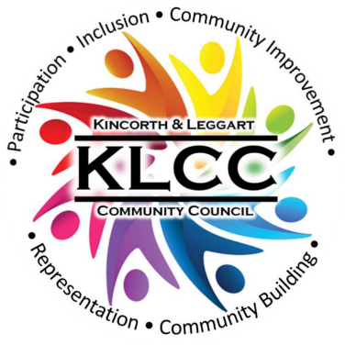 | Kincorth & Leggart Community Council  MAY Meeting Minutes  Wednesday 13th May 2026  Room No 7, Kincorth Community Centre

Attendees: Hazel Massie, Kirsty-Lee Murray, Ivan Irvine, Scott Sutherland, Joyce Leslie, Cllr Richard Brooks, Cllr Miranda Radley, Cllr Lynn Thomson, Patricia Watt, Shelagh Morrison, Chris Sumner

Apologies: Dorothy Burke, Amanda Foster, Cllr Alex Nicoll, Alexander Galashan, Donna Cuthill,

Chairperson’s Report
Our Chair opened the meeting and welcomed everyone.

The April Minutes were approved by Joyce and seconded by Shelagh; they should now be posted on Facebook and our Web page. ACTION: Secretary

Police Report
Members highlighted continued concerns raised by residents on the high use of electric bikes, scooters and motorcycles. The antisocial behaviours shown by these users have angered residents and they even access Sheltered housing areas at Margaret Clyne and Mark Bush. Action: KLCC to highlight concerns to Police

For information, contact the Police as follows
-  101 – Non emergency;
-  Email - AberdeenSouthCPT@scotland.police.uk
-  Twitter - @NorthEPolice
-  Facebook – www.facebook.com/NorthEastPoliceDivision
-  Web – www.scotland.police.uk
-  999 – Emergency;
-  0800 555 111 - Crimestoppers;

Councillor’s Reports
Outstanding issues from previous meeting:-
Flooding Issues
We have an issue with blocked road gulleys not being cleaned (in general) in Kincorth. The result is that many roads have heavy flooding during rain. Examples from community council included: -
- Flooding at Corthan Crescent - not as big as it used to be, but it is still an issue
- Gardener Crescent/Drive, three areas of flooding happen here
- Faulds Gate, is difficult for school crossing during persistent rainfall
Action: Cllr Brooks to chase for action

Grit bin location map and bin status – Cllr Radley working on identifying the condition and location of each bin in the Kincorth area and will email her findings to the Committee. Action: Cllr Radley

Housing Development Obligations
Ogilvie Construction will be invited to attend the next KLCC meeting in June. Action: Secretary

Council Payment Machine within Kincorth Community Centre
Cllr Brooks has raised this removal and will again ask when the machine will be uplifted from the premises. Action: Cllr Brooks

Litter on Hareness Raod & Altens Farm Road
Ref. : FS-Case-817940961 Summary: Litter on Hareness Road and Altens Farm Road As the enquiry required input from more than one service, the Customer Feedback Team have collated the information and can provide the following response: - Thank you for your enquiry. This concern will be highlighted to City Wardens and NES enforcement officers, so they can both provide patrols and enforce littering offences if seen. A crew from our Street Sweeping Team attended on Tuesday 31st March 2026 and cleared the area.

Cllr Thomson is dealing with case work and her surgeries at the CC are now back in place.

Cllr Radley informed the committee that budget cash has been set aside with a programme for blocked gullies, city centre cleaning and a fly tipping hit squad.

Treasurer Report
Most of the expenditure incurred this period are related to the Open Space Event being held on Saturday 16th May 2026.

TSB bank account nominees are progressing, and it is hoped that the account will be fully functional by our next meeting.

We are awaiting our Annual Grant award; this has been held up due to a new financial system being installed.

Planning Report
HazelntsNBrambled Project
The 30 fruit trees along Nigg Way are subject to rabbit and Deer damage. There was no budget for protectors which may not have stayed in place. They have been given a spray to discourage further eating to improve the percentage survival.

NESTRANS funding granted for picnic table and bench. The picnic table will replace the existing facility and a new bench at a location to be identified. The wording for the attached plaque will reflect NESTRANS donation and KLCC input, when decided

South Harbour Road Link and Wellington Road Corridor
Charlie Abel, Chairman of Nigg Community Council, has written to Cllr Ian Yuill with our collective concerns (i.e. All 4 Community Councils, Kincorth/Torry/Nigg/Altens) and we hope to have a meeting to discuss these concerns prior to the Net Zero Meeting scheduled for 10th June. Further information and meeting date will be sent out to members. Action: Ivan/Secretary

KLCC Survey
The “Open Space Event” in the Kincorth Community Centre will be held on Saturday 16th May from 10:00 hrs – 13:00 hrs all residents have and will be invited via flyers, posters and Facebook.

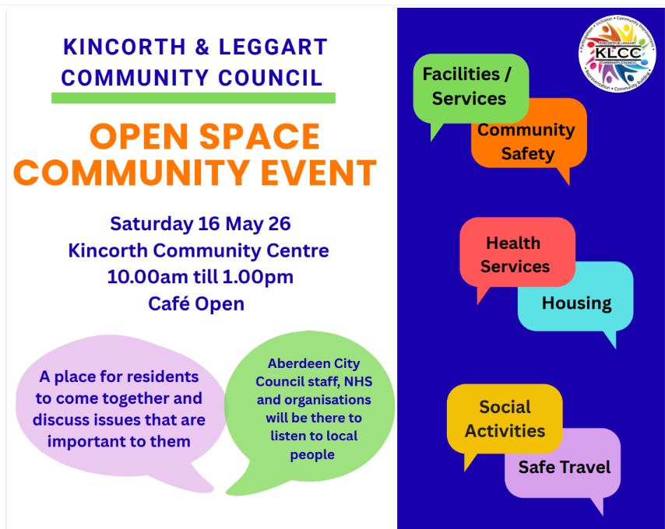 | 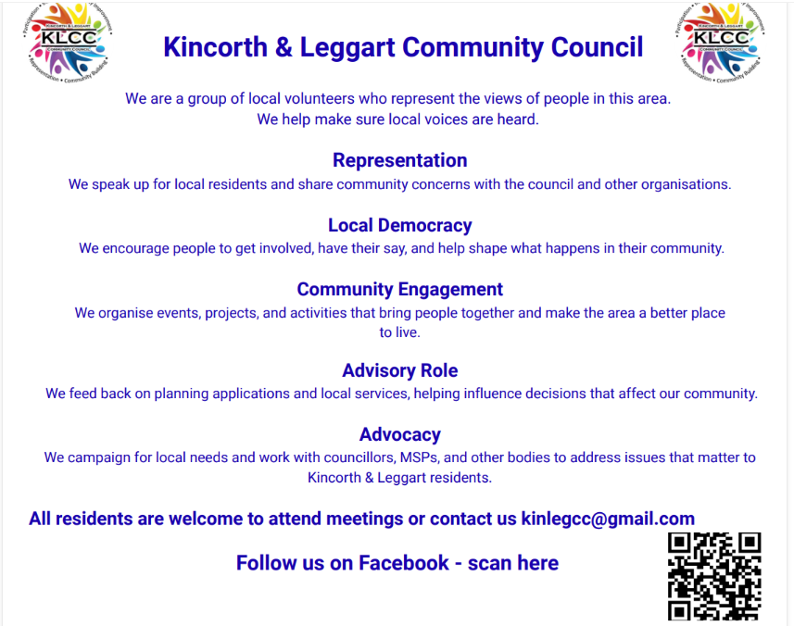

The Community Consultation: Analysis Summary Report can be viewed on our Web Page. Link: https://klcommunitycouncil.org.uk/community-survey/

Notice Boards
From the KLCC Survey, improving communication was one of the priorities identified and to assist with that we shall purchase two Notice Boards i.e.one for the Gardner Shops and one at the Kincorth Shops.

The Gardner Shops Notice Board has been installed. Action: Committee members to organise key access, contents and update frequency.
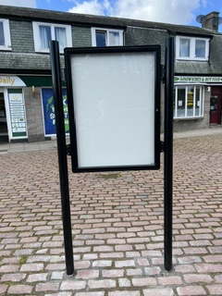

Johann Cruyff Football Court
The term Cruyff Court no longer applies to Kincorth. We now refer to Kincorth Bowling Green Development. We received agreement that Aberdeen City Council will retain the £700,000 to build a multi sports facility on the old bowling green next to the Sports Centre. Council Officers will assess the area and prepare a Business Case for the next Finance & Resources Committee meeting due August/September 2026.

Cllr Radley said that she will keep us informed with any updates/progress. Action Cllr Radley

Deevale Community Garden
(accessed via the lane at the corner of Cairnvale Terrace and Deevale Gardens)
Lots of work going on, preparing beds and planting.

The community gardeners are working towards becoming a constituted group and hold regular meetings to discuss projects.

The group have been successful in achieving a Cfine Music Event which will be combined with this year’s 3rd Garden Birthday Party in Summer. Dates and event details to be decided but hopefully either the 1st or 2nd Saturday in July will see the event kick-off.

KLCC members agreed to support the event with a donation of up to £50 and the group are trying to source the use of a Gazebo in case of inclement weather conditions. Action: Shelagh/Treasurer

Gardner Residents Project
Gardner residents are still waiting for the Council to take action on the issues highlighted in the walk around in January.

Great news that the Gardner Notice Board is now in place.

We need more volunteers and your voice matters, make them heard by joining in the Gardner Community Group, contact us at gardnergreenspace@gmail.com or dcuthill@aberdeencity.gov.uk

AOB
Champion Street Children’s Football Tournament (75 teams will participate)
Monday 13th July – Sunday 2nd August all on the grass pitches at Kincorth Circle.
The main organiser of this event is Dani Kindness from Kincorth Emirates Youth Football Club and Dani has asked that the Kincorth Community Centre be open at relevant times for toilets, rest area and café. Action: Scott to discuss with KCCH

Kincorth Family Fun Day & Legends Day
Proposed date Saturday 25th July all on grass pitches at Kincorth Circle.
KLCC hope to participate in the event and have a Tombola Stall, event details ongoing. Action: KLCC to communicate with KCCH re event

Disability/Mobility Issue
Margaret Clyne Court residents including those in wheelchairs and mobility scooters highlighted the following problems to be raised at the meeting:-
- The pavement on Kincorth Circle is damaged, holes and fractures from the front of Margaret Clyne Court to Kincorth Community Centre makes it difficult for all walking and even hazardous for residents using wheelchairs/scooters.
- The crossing from the top of Provost Watt Drive near the Community Centre to the Spar, the pavements have been lowered to an extent but not sufficiently for residents who use wheelchairs/scooters. Residents are stuck and stranded on the central grass reservation on the road which is right in the middle of free-flowing traffic.
Committee members to highlight these issues with local Councillors to see if any action can be taken. Action: Secretary to email local councillors with this minute extract

Ogilvie Construction Ltd, Housing Developer
KLCC have been approached by Cheryl Christoforos (Site Administrator/Document Controller) who is supporting the Project Director, John Walker with the Community benefits on the Kincorth affordable housing development site and they wanted to meet and discuss how they can support the community. Action: Secretary to invite them to the next meeting on 10th June

KLCC Pop-Up Banner
The committee agreed to purchase a pop-up banner for use at events. A proposed design/layout will be presented for approval. Action: Secretary/Donna

Laptop and Printer
The Secretary proposed purchasing a laptop and printer for sole use by the committee members and this was agreed. There is money remaining from the Udecide Xmas Grant and permission has been requested to use this money towards the purchases. Action: Secretary to source suitable laptop/printer and costing, look at KLCC Gmail account and set up for everyone to access and report back at the next meeting.

Date of Next Meeting
10th June 2026 in the Kincorth Community Centre, Room 7 at 18:30 hrs.

Date of future Meetings - all within the Community Centre, Room 7, starting at 18:30 hrs.
8 July, 12 Aug, 9 Sept, 13 Oct, 11 Nov, no December meeting.

