 | Kincorth & Leggart Community Council  DRAFT MAY Meeting Minutes  Wednesday 13t^{h} May 2026  Room No 7, Kincorth Community Centre

Attendees: Hazel Massie, Kirsty-Lee Murray, Ivan Irvine, Scott Sutherland, Joyce Leslie, Cllr Richard Brooks, Cllr Alex Nicoll, Alexander Galashan, Donna Cuthill, Cllr Miranda Radley, Kazah-Ambrang Bagro, Technical Officer ACC City Regeneration & Environment/Operations, Vycki Ritson ACC Traffic Management & Development Team Leader

Apologies: Cllr Lynn Thomson, Patricia Watt, Dorothy Burke, Shelagh Morrison, Chris Sumner, Amanda Foster, Terry Massie

Chairperson’s Report
Our Chair opened the meeting and welcomed everyone.

An update was requested to the March Minutes and then approved by Joyce and seconded by Kirsty-Lee. Minutes should now be posted on Facebook and our Web page. ACTION: Secretary

Police Report
At the most recent Community Council Forum, many Community Councils expressed their disappointment on the contents of the quarterly report. The Police have taken this on board and will endeavour to make it more relevant to the area being reported. They have also stated that Police will attend a CC meeting every 6 months.

For information, contact the Police as follows
-  101 – Non emergency;
-  Email - AberdeenSouthCPT@scotland.police.uk
-  Twitter - @NorthEPolice
-  Facebook – www.facebook.com/NorthEastPoliceDivision
-  Web – www.scotland.police.uk
-  999 – Emergency;
-  0800 555 111 - Crimestoppers;

Councillor’s Reports
A member asked for a follow-up on the road gullies that are blocked on Gardner Road, Gardner Crescent and the Gardner Shops. Action: Cllr Brooks to investigate

Grit bin location map and bin status – Cllr Radley working on identifying the condition and location of each bin in the Kincorth area and will report to the next meeting. Action: Cllr Radley, she will also identify who is responsible for the grit bin at the Doctors surgery.

Case Ref 78625458: two bus shelters at the top of Provost Watt Drive.
ACC response with regards to the 2 damaged shelters on Provost Watt Drive adjacent to the shopping arcade: “ACC have had the shelters inspected and have decided to have them replaced with new ones, and these will be financed from the 2026/27 budget. As a number of bus shelters across the city will be part of the replacement project, this will take time to plan. ACC have therefore arranged with the Provost Watt Drive shelter suppliers to provide a quotation for temporary repairs, which could mean boards where the Perspex panels were originally. This will obviously be a temporary solution however the alternative to this would be to have the damaged shelters removed, leaving no shelter in the interim, which we would prefer not to do.
At present, ACC cannot provide dates for the new installations however we will begin liaising with the proposed suppliers of the new shelters in the coming weeks. Once dates have been agreed for replacement, ACC will contact directly by email with an update.”

FS-Case-653506852: Faulds Gate, request for pedestrian crossing
- ACC response is that the PV2 survey carried out at the location does not meet the criteria required for the installation of a formal crossing.
- Members highlighted several issues re the crossing: eg: signage is old and some are blocked by trees.
- ACC also explained that it is very difficult obtaining a Lolly Pop person to carry out traffic management.

Housing Development Obligations
Cllr Nicoll has given KLCC and KCCH guidance on what would be acceptable as a Capital spend and has offered support going forward.

Council Payment Machine within Kincorth Community Centre
Cllr Brooks investigated reinstatement of the machine but due to budget restraints this will not happen and in fact the machine should have been removed from the premises some time ago. Action: Cllr Brooks will chase up the removal.

Cllr Radley informed the members that road repairs on the Bridge of Dee Bridge should commence soon, starting approx. 1st May.

Treasurer Report
Our new Treasurer, Alexander Galashan has undertaken his training for the position.

As agreed at the meeting we are going to continue with the TSB Bank as there are no annual fees incurred with this account. We have provided the TSB with all the account administrators names etc. and we are now just waiting for the account to be updated which will then allow Alexander to take on his full role.

We are awaiting our Annual Grant award; this has been held up due to a new financial system being installed.

Planning Report
Vycki Ritson and Kazah-Ambrang Bagro attended the meeting to discuss the traffic measures on the South Harbour Link Road. KLCC members have already forwarded some concerns and a joint meeting of all the Community Councils affected i.e. Kincorth/Nigg/Cove has been arranged for 14th April to collate and forward everyone’s opinions and concerns.

HazelntsNBrambled Project
The 30 fruit trees have been planted this week along Nigg Way and there are another 30 for the Nature Reserve. Approval from KLCC was received to forward TSB Bank Statement to NESTRANS regarding our funding application which is in progress for a picnic table and benches. KLCC was advised that this is a normal request from funding organisations.

KLCC Survey
The “Open Space Event” in the Kincorth Community Centre will be held on Saturday 16th May from 10:00 hrs – 13:00 hrs all residents are cordially invited to attend.

A flyer advertising the event will be sent to all residents via Royal Mail between 27th April and 4th May. During this period a formal email invitation will also be sent out and notices advertising the event will be visible in all local shops/businesses.

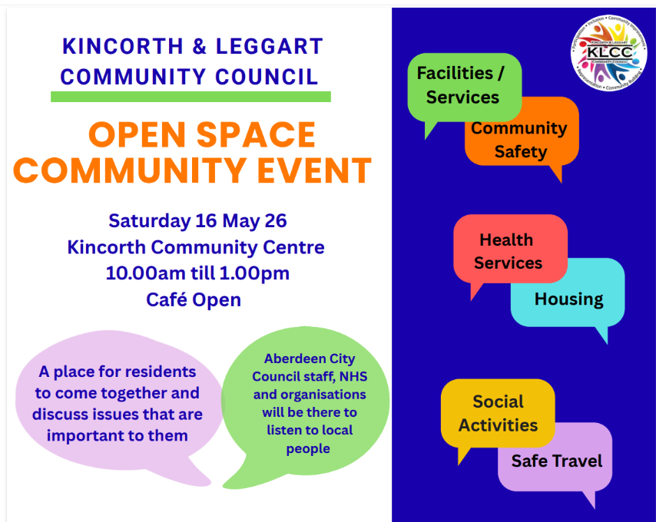 | 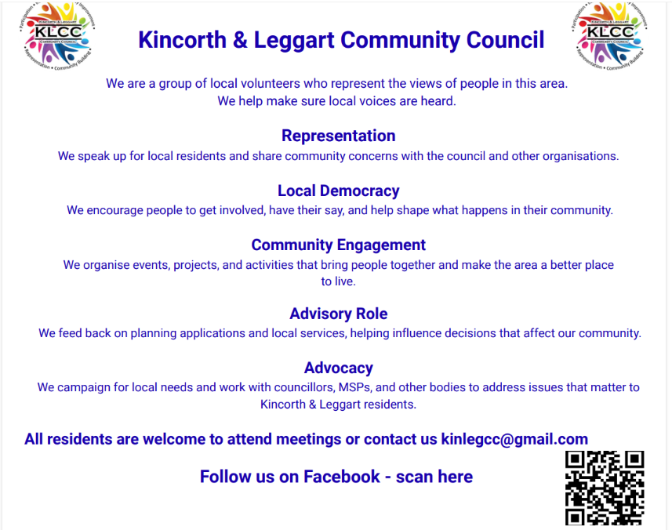

The Community Consultation: Analysis Summary Report can be viewed on our Web Page. Link: https://klcommunitycouncil.org.uk/community-survey/

Notice Boards
From the KLCC Survey, improving communication was one of the priorities identified.

There will be two Notice Boards, one at the Gardner Shops and the other outside the Kincorth Shops. Action: Donna to chase up installation.

Johann Cruyff Football Court
The Kincorth community preferred site remains the unused bowling green adjacent to the Sports Centre in Corthan Crescent.

Aberdeen City Council has offered a single site meeting starting at 15:30 hrs on Monday 13th April on the open grass area at Kincorth Circle. Kincorth representatives will be in attendance.

The matter will return to Aberdeen City Council Finance and Resources Committee Meeting at 10am on Wednesday 13th May in the Town House, Broad Street. This meeting is open to the public and Kincorth representatives will be in attendance. Action: Representatives will attend the Finance & Resources Committee Meeting on 13th May.

Deevale Community Garden
(accessed via the lane at the corner of Cairnvale Terrace and Deevale Gardens)
Lots of work going on, preparing beds and planting. We have recently purchased a cordless strimmer and some new garden tools. Tesco Langstracht kindly donated compost, bedding plants, 2 solar garden lights and lawn feed. Gardener Jim is donating an 8-seater picnic table.

We held our first garden meeting of the year and made the following decisions:
- Unanimous decision to become a constituted group
- Agreed the high priority communal tasks for the coming months
- Agreed to host our 3rd Garden Birthday Party in the Summer

Gardner Residents Project
Almost all the bulbs have been planted. It’s good to see last years bulbs blooming.

We are disappointed that not a thing has been repaired or maintained that was highlighted on our walk around. Especially the reported raw sewage issue at the Gardner Shops which has still not been resolved. These repairs and maintenance are more than necessary. We have repeatedly reported these issues. Residents feel the next step is going to the papers.

It was suggested members join the Tenants and Residents Group but unfortunately as it is predominantly online, this is not appropriate for the majority of our members. We encourage residents to continue reporting repairs and maintenance and to complain when action is not taken.

Although we still have an ongoing issue with fly tipping, we are very grateful of the regular pick-ups.

We need more volunteers and your voice matters, make them heard by joining in the Gardner Community Group, contact us at gardnergreenspace@gmail.com or dcuthill@aberdeencity.gov.uk

AOB
Nothing to report.

Date of Next Meeting
13th May 2026 in the Kincorth Community Centre, Room 7 at 18:30 hrs.

Date of future Meetings - all within the Community Centre, Room 7, starting at 18:30 hrs.
10 June, 8 July, 12 Aug, 9 Sept, 13 Oct, 11 Nov, no December meeting.

