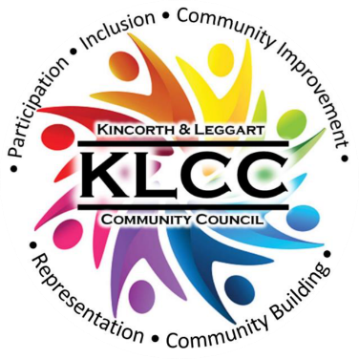 | Kincorth & Leggart Community Council DRAFT November Monthly Meeting  Wednesday 12th November 2025  Room No 7, Kincorth Community Centre

Attendees: Hazel Massie, Lisa Falconer, Kirsty-Lee Murray, Cllr Alex Nicoll, Shelagh Morrison, Chris Sumner, Ivan Irvine, William Wilson, Scott Sutherland, Joyce Leslie, Donna Cuthill

Apologies: Cllr Richard Brooks, Cllr Miranda Radley, Cllr Lynn Thomson, Pat Watt, Dorothy Burke, Amanda Foster, Amelie Prevost

Chairperson’s Report
The Chair opened the meeting and expressed sad thoughts on the loss of one of our members, Richard Watt, who passed away recently. The Committee expressed their fondness for Richard and took some time to reflect. We have sent our deepest condolences to his wife Patricia Watt who is also a committee member. Members will be attending Richard’s funeral service on 18th November.

The Chair talked about good etiquette in meetings and referred members to the Code of Conduct and Constitution. This was highlighted to members to ensure good use of time at meetings, especially when raising individual resident’s issues to Councillors. It is requested that we keep our Councillors time at our meeting to address the bigger issues and that individual enquiries should be logged on-line. If anyone does not have Computer access or skills, then the housing officers have kindly offered to complete the on-line request on their behalf. Link: https://www.aberdeencity.gov.uk/ ACTION: Secretary to email all the Code of Conduct and Constitution to members.

Outstanding issues from the previous Minutes to be carried forward:-
- Lighting at the back of the CC – Laura Barry/Kirsty-Lee
- Is the Kincorth Doctors Surgery included in the ACC Grit Plan? – Cllr Nicoll
- Kirkhill School railings – Cllr Nicoll
- Cairngorm Road crossing proposal feedback to Cllr Brooks (on Agenda going forward as Cllr Brooks unable to attend this meeting)

The October Minutes were approved by Shelagh and seconded by Joyce. They should now be posted to Facebook and our Web page. ACTION: Secretary

Police Report
We have been informed by the Police that there will be a quarterly Report emailed to Community Councils going forward starting from 1st December 2025. Action: Secretary to follow-up

Councillors Reports (Cllr Alex Nicoll)
Alex pointed out that ACC were in discussion with the development and assessment of route options to provide improvement junction links on Wellington Road from Charleston Road North to Craigshaw Drive. There is a public consultation being held on 18th November in the Aberdeen Altens Hotel from 12 noon – 7pm in the Albyn Suite. He encouraged members to attend as it will have an effect on the community and he suggesting that the KLCC should talk to other affected Community Councils.

He informed the Committee that the 12% Council tenant rent increases will be going ahead.

Alex reiterated that residents need to report any empty grit bins to ACC so that they can be refilled. Here are the links:-

https://integration.aberdeencity.gov.uk/en/service/grit_bin_empty_or_damaged___report
https://www.aberdeencity.gov.uk/services/people-and-communities/get-ready-winter/one-tonne-salt-bags

Treasurer Report
All expenditure this month is for the Christmas Event on 27th November.

Remembrance Service Day 9th November
KLCC was represented by Kirsty-Lee Murray who laid a wreath on our behalf.
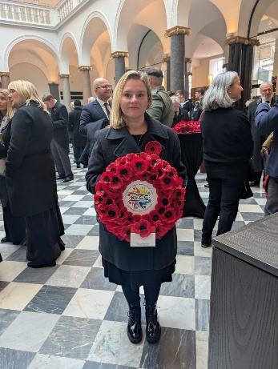

Christmas Event & Lights Switch-on
This year we are delighted to be joining Abbotswell School Parent Council for a joint Christmas Event on 27th November to be held in Mark Bush Court from 4-6pm. In discussion with Scotia and our Councillors, it is very much hoped that our Christmas Lights will be erected on the lampposts of Provost Watt Drive for the event and we look forward to seeing you all there.



KLCC Survey
The Community Consultation: Analysis Summary Report has been completed and distributed. The Report is on Facebook and our Web site under the heading “Community Survey”: https://klcommunitycouncil.org.uk/community-survey/

KLCC “Open Space Event” for all residents and key players schedule for Saturday 8th November in the Community Centre has been postponed and will hopefully take place in March 2026. Action: KLCC subgroup

An action from the Survey was to install a stand-alone Notice Board in Kincorth to aid communications. The location and permission to install has been granted. Kirsty-Lee will now source a suitably sized notice board and apply for funding to install. ACTION: Kirsty-Lee/Donna to support

NESCAN Fund LEAF Fund (Gramps Gorse removal) – The work has been carried out by PCCS Ltd and when the Invoice for the work is submitted it will be paid with money received from the fund. ACTION: Ivan/Secretary

Kincorth Play Parks
It is planned that in the New Year, members in conjunction with residents, maybe ACC members and councillors formalize a plan to walk round each of the play areas in Kincorth and survey the sites. This information can then be used to progress any future discussions with ACC on suggestions for improvement. It was mentioned that play equipment had been removed from Mathews Road and we need to ask if this is being replaced. ACTION: Committee Members

Johann Cruyff Football Court
There has been no feedback regarding the proposed location of the Cruyff Count and its now 9 months since the announcement. The subject will be coming back on 10th February 2026 to the Finance Committee. Councillors and Members are keeping a close eye on any developments.

Deevale Community Garden
(accessed via the lane at the corner of Cairnvale Terrace and Deevale Gardens)
- The gardeners met in October and agreed a Code of Conduct, talked about purchases with the remaining funds and finalised a to do list.
- Steven Shaw and the Rangers donated 2 'Meadow in a Box' planters, complete with compost and wildflower plants.
- We've had to dig in the skirt of the polytunnel twice as it's come loose and we're now hoping it will hold through the worst of the weather.
- Spring bulb planting will be done once the bulbs have arrived.

Gardner Residents Project
We had a meeting on the 27th of October. Meeting with Steven Shaw from the environmental team and Dorothy from the development team. The housing officer and councillors were invited, unfortunately unable to attend. Apologies to Cllr Nicoll, who was missed from the invitation email.

Gardner residents thanked Steven and team for their hard work. We have seen a lot more maintenance to the grass and hedges this year. Trees in the area have been inspected. Some have had maintenance, they're deemed healthy. Steven offered us some planters to go by our newly refurbished bench. Of course we said yes.

Unfortunately, residents had reported difficulty in reporting and receiving repairs and maintenance to their homes. Inside and outside. Residents noted an increase in mold and damp in their properties. The drains and gutters are blocked and broken. Roof tiles are missing. As it was a wet day the sour smell of drain water was noticeable. Through paths were flooded. So were the roads. The drains are blocked and plants are growing from them. The front doors aren't secure. The verandas are not secured in netting to prevent pests.

Some through path lights, stairwell lights and street lights aren't working. This has been reported to the housing team. We look forward to a response and some action.

Residents were encouraged to keep reporting repairs, maintenance and fly tipping. To chase it up or complain when the work is not completed. They were reminded that the housing officer is available every Thursday at the community centre.

Returning to the green space project. The cellar remains the same. Members have chased up the housing team on repairs. The Calor gas canister has been removed.
The Craighill site is coming along. So far we have noticed 3 small areas with wooden play apparatus. This is great, though there is room for improvement. With 33 new 3 bedroomed homes soon to be filled there's going to be even more children in the area. We have room for a safe play space. We understand it's a big ask but with the opportunity of developers funding; as the saying goes, “If you don’t ask you don't get”.
We'd love to do a walk around the area with anyone who can help us going forward with any of the above.

We need more volunteers! The more people we have the more we can do. If you would like to get involved, please contact Donna Cuthill on Email: dcuthill@aberdeencity.gov.uk or Kirstylee Murray on Email: kleepopo@googlemailcom.

AOB
On the 25th of October in Edinburgh, KLCC members participated in the Scotland Demands better march. We marched to demand better for all. To demand immediate action on the housing crisis and the mental health crisis, which are magnified by the cost-of-living crisis.

Date of Next Meeting
There is no December meeting. Our next meeting will be on Wednesday 14th January 2026 in the Kincorth Community Centre, Room 7 at 18:30 hrs.

All 2026 meeting dates have been forwarded and acknowledged by Andrea/KCCH and Karen Finch on 11th November 2025.

Date of future Meetings - all within the Community Centre, Room 7, starting at 18:30 hrs.
11 Feb AGM, 11 March, 8 April, 13 May, 10 June, 8 July, 12 Aug, 9 Sept, 13 Oct, 11 Nov, no December meeting.

